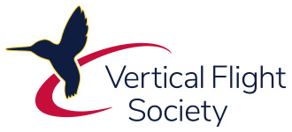
VFS LUNCHEON

Title: Rotorcraft Crashworthiness Design and Testing
Speaker: Dr. Karen Jackson, VFS/AHS Tech Fellow and AHS 73rd Forum Nikolsky Honorary Lecturer
Topics: Overview of rotorcraft crashworthiness design discipline, impact on civil and military crew & passenger survivability, and demonstrated successes.
​​Deadline for​ reservations: 1100 Wed, 10 Jun 2026

Time: 11:45 Check-in & Networking; lunch ordering
12:05-1240​ Presentation
12:45-1:15 Lunch
1:30 End of Luncheon
​​
Location: Angelo’s Steak & Pancake House, 755 J. Clyde Morris Blvd, Newport News, VA
Cost: Free to current VFS HRC members (or those joining VFS onsite)
​
POCs: HRC Tech Prog Chair vp@vfshrc.onmicrosoft.com
Guests Are Welcome, pay as you go!!

